HP3932C 32 in 1 IP QAM Modulator

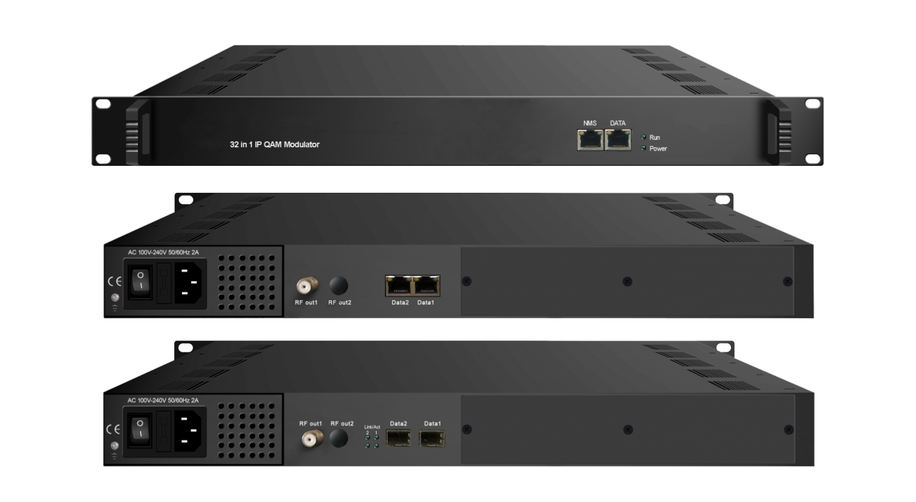

Product Overview
HP3932C 32 in 1 IP QAM modulator is the latest generational Mux-scrambling-modulating all-in-one device developed by CATCAST. It supports maximum 1024 IP input through the 3 GE ports and 32 multiplexing scrambling QAM (DVB-C) modulating channels with non-adjacent carriers (50MHz~960MHz) output through the RF output interface. Its pay-as-you-grow modular design and flexible configuration are making it extremely scalable, very reliable with high performance, all of which are adaptable to newly generation CATV broadcasting system.

Key Features

l 3 GE ports (max 1024 IP in):
Data1 & Data2 bi-directional ports, max 512 IP in, 32 IP out
Data port (located on front panel), max 128 IP in
l Max 840Mbps for each GE input
l Supports accurate PCR adjusting/CA filtering, PID remapping and PSI/SI editing
l Supports up to 256 PIDS remapping per channel
l Support 32 IP output through Data1 & Data2 over UDP/RTP/RTSP
l 32 non-adjacent QAM carriers output, compliant to DVB-C (EN 300 429) and ITU-T J.83 A/B
l Supports RS (204,188) encoding
l Support Web-based Network management

Inner Principle Chart

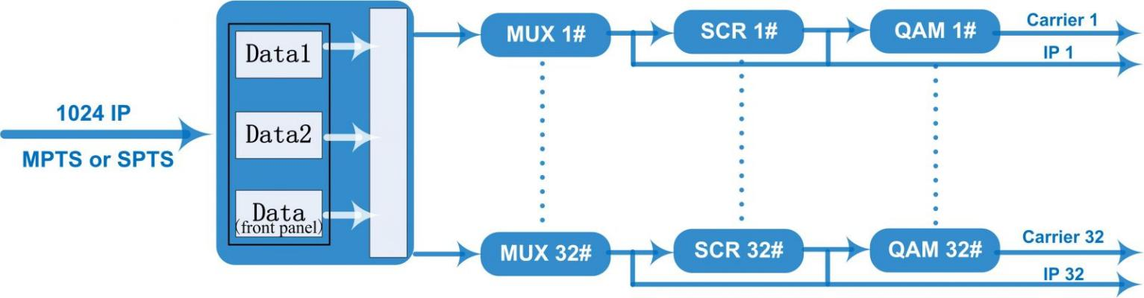

Carrier Setting Illustration
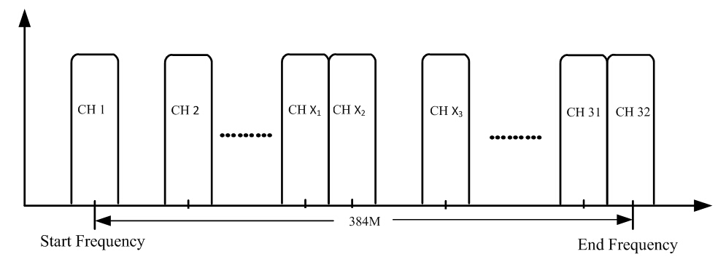

System Connection Sample (IP Based)

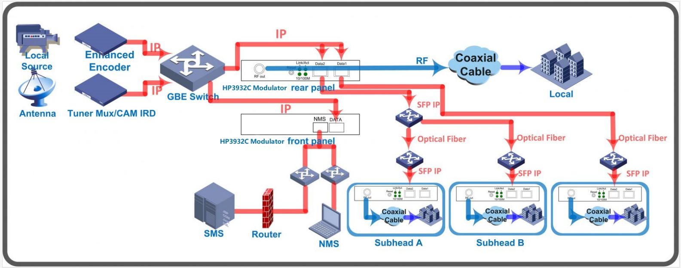

Specifications

Input | Input | Max 1024 IP input through 3 (front-panel Data port, Data 1 and Data 2) 100/1000M Ethernet Port (SFP interface optional). Each Data1 or Data 2 port can input maximum 512 IP, while front-panel Data port can input maximum 128 IP
Input | Transport Protocol | TS over UDP/RTP, unicast and multicast, IGMP V2/V3
Input | Transmission Rate | Max 840Mbps for each GE input
Mux | Input Channel | 1024
Mux | Output Channel | 32
Mux | Max PIDs | 256 per channel
Mux | Functions | PID remapping(auto/manually optional)
Mux | Functions | PCR accurate adjusting
Mux | Functions | PSI/SI table automatically generating
Scrambling  Parameters | Max simulscrypt CA | 4
Scrambling  Parameters | Scramble Standard | ETR289, ETSI 101 197, ETSI 103 197
Scrambling  Parameters | Connection | Local/remote connection
Modulation  Parameters | DVB-C Modulator Section | J.83A | Constellation : 16/32/64/128/256QAM
Modulation  Parameters | DVB-C Modulator Section | J.83A | Bandwidth :8M
Modulation  Parameters | DVB-C Modulator Section | J.83B | Constellation : 64QAM/ 256QAM
Modulation  Parameters | DVB-C Modulator Section | J.83B | Bandwidth :6M
Modulation  Parameters | QAM Channel | 32 non-adjacent carrier
Modulation  Parameters | Modulation Standard | EN300 429/ITU-T J.83A/B(DVB-C)
Modulation  Parameters | Symbol Rate | 5.0~7.0Msps, 1ksps stepping
Modulation  Parameters | Constellation | 16, 32, 64 , 128, 256QAM
Modulation  Parameters | FEC | RS (204, 188)
RF Output | Interface | 1 F typed output port for 32 carriers, 75Ω
RF Output | RF Range | 50~960MHz, 1kHz stepping
RF Output | Output Level | -20dBm~+10dBm(87~117dbµV), 0.1dB stepping
RF Output | MER | ≥ 40dB
TS output | 32 IP output over UDP/RTP/RTSP, unicast/multicast, 2 (Data1& Data2) 100/1000M Ethernet Ports
System | Network management software (NMS) supporting
General | Demission | 420mm×440mm×44.5mm (WxLxH)
General | Temperature | 0~45℃(operation), -20~80℃(storage)
General | Power Supply | AC 100V±10%, 50/60Hz or AC 220V±10%, 50/60Hz

